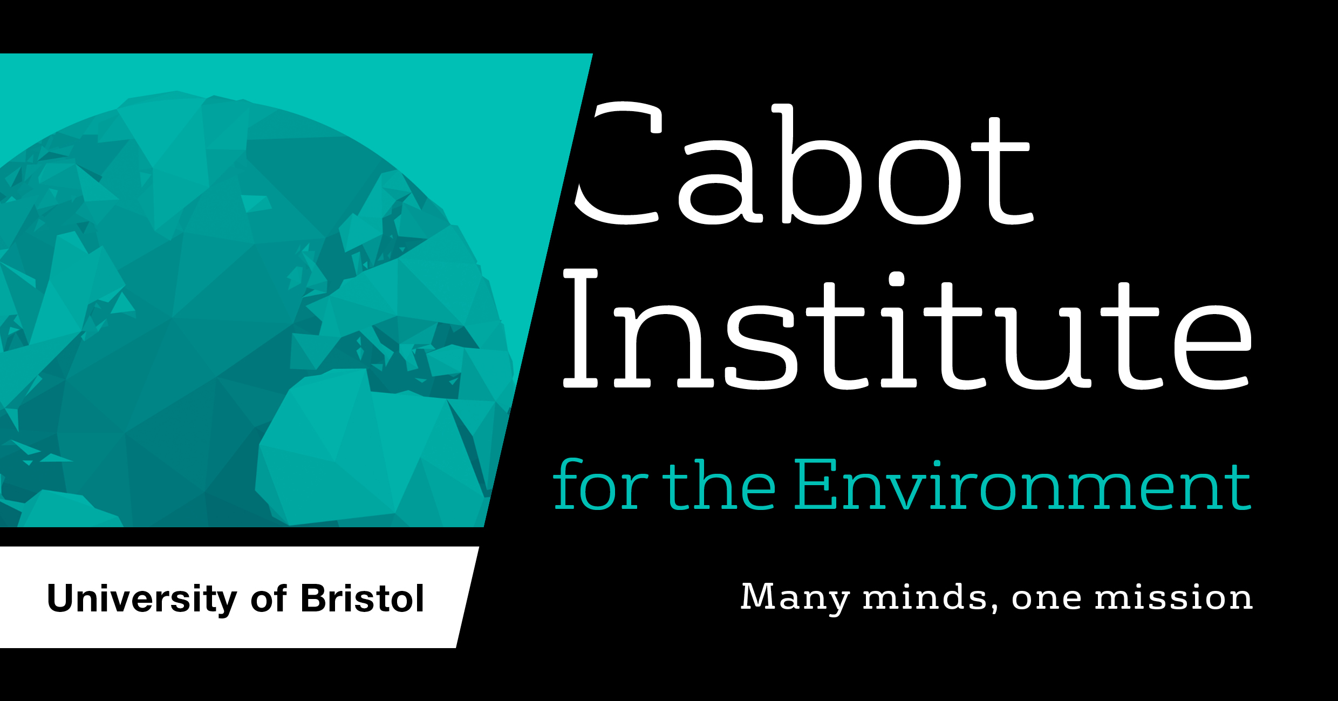

2022 Cabot Institute Innovation Fund: Application guidelines
We are delighted to announce the annual call for proposals to the Cabot Institute Innovation Fund, which is supported by the generous donations of alumni and others to the Institute. The fund has two main aims: to pump prime genuinely new and exciting interdisciplinary research ideas with a view to developing major future proposals, and to support impact or engagement-focussed activities that help new, relevant audiences engage with and shape Cabot Institute research.
Funding is available to support bold, ambitious and impactful projects. The funding will be distributed between the highest-ranked projects.
Please read the following guidance carefully:
- All applications must reflect the Cabot Institute’s interdisciplinary and engaged research approach, which brings together researchers from across disciplines and faculties, or involves non-academic partners.
- Applications must reflect the Cabot Institute’s research focus on protecting our environment and identifying ways of living better with our changing planet.
- We welcome applications on any relevant topic, from all areas of the University, that meet the criteria above.
- Funds are available to pump-prime new research activity, or to help deliver impact or engagement.
- Applications aimed at producing major research bid submissions, and those involving more than one faculty, will receive priority.
- This call is open to anyone eligible to apply for research grants. However, it is possible to involve students in the delivery of your proposal.
- To apply, please complete and submit the attached application form, outlining the nature of the project to be developed, including internal and external project partners, expected outputs and longer-term intended funding sources. Applicants must provide information as to how the Cabot Institute funds will be used.
- Applicants are strongly encouraged to discuss ideas for their proposals with the Cabot team prior to submission. Please contact vicky.jones@bristol.ac.uk
- Awarded funds must be spent by 31 July 2023.
If you have any questions, please contact Vicky Jones: vicky.jones@bristol.ac.uk
We encourage you to discuss your ideas with us before applying
Please send all completed applications, as a Word document, to: vicky.jones@bristol.ac.uk
Closing date: 9am Monday 1 August 2022
Awards announced: mid-September 2022

Funds for pump-priming research

Funding available: Typically £4k-£5k (Exceptionally up to £7k) per grant. We would anticipate awarding the majority of funds to these activities, but will select the highest ranked projects, regardless of the scheme.
Pump-priming funds are intended to help develop interdisciplinary research groups or consortia, and to support scoping activities. Funds can be used to cover costs associated with the development of interdisciplinary research bids (including people e.g. post doc and PhD students, travel, consumables, events), scoping activities, or pilot studies leading to major proposals.
The expected outcome is a significant grant submission, ideally co-developed with end users.

Funds for impact and engagement activities

Funding available: Typically £250 -£2k (Max £5k) per grant.
To help build an engaged and multidisciplinary community of researchers that extends beyond the University, we are providing funds to run seminars, workshops, conferences and other impact/engagement-focused activities.
All events must be on a topic within the Cabot remit, and should be multidisciplinary and/or engage stakeholders or the public. Applicants are encouraged to develop innovative formats for engagement.
Funds can be used for people, travel, consumables and events. Applicants for conference funding are encouraged to seek matched funding/sponsorship from other sources.
Expected outcomes include: enhanced networking and relationship-building within and outside the University (including academics, public and third sector organisations, business and policymakers); translation of existing research into impact; contribution to future REF impact case studies; high profile agenda-setting discussions that position Bristol at the heart of emerging ideas.
Examples of previous awards can be found on the Cabot Institute website

Worktribe costings
The application must be fully costed on Worktribe and approved by your Head of School, before submission. The table below shows the information that should be added for the following fields:
Project Type | Donations – restricted
Project Activity Type | Research – Internally Funded
Funder | University of Bristol (Internal Funding Call)
Scheme | UoB (Internal) 100% DI costs
Name of Call | Cabot Institute Innovation Fund

PLEASE DELETE THE PAGES ABOVE BEFORE SUBMITTING YOUR APPLICATION
2022 Cabot Institute Innovation Fund: Application Form

Title of proposed project

Main applicant
Department
Email address

Co-applicant
Department/Organisation
Email address
(Please duplicate this section as necessary for additional co-applicants)

Are you applying for:
Pump priming |  | Impact/ engagement

- What is the challenge, what do you want to do, and how will it help?
If your application is successful, we will use this text on the Cabot Institute website. Please use accessible language. Max. 250 words.

- How does your project fit with the Cabot research agenda of ‘protecting our environment and identifying ways of living better with our changing planet’? Max. 150 words.

- Who is involved and why do you want to work together? Please explain the interdisciplinary aspects of the project, what each team member (including external partners) will bring to the project, and whether this is a new partnership or building on existing relationships/projects. Max. 250 words.

- What will happen as a result of this work? What are the short and long-term outcomes and/or outputs (e.g. enhanced relationships, grant submissions, new research ideas, personnel exchanges, or papers, other publications, audio or video footage) Max. 250 words.

- What funding do you require? Please give a cost breakdown and justification of individual items. Max. 200 words.
Please note, the application must be fully costed on Worktribe and approved by your Head of School, before submission. Please include your Worktribe reference number below.
Indirect costs and estates costs are ineligible for this fund.

If you are successful in your application we would like to feature your work on the Cabot Institute website and in publications. We will also contact you after your project has completed for input to a short (max 500 word) report for Innovation Fund donors. We may also contact you in subsequent years to ask about the longer term impact of your award. Please check the box to indicate you understand this expectation, and are willing to help communicate your work widely.

After the award has completed we may invite you to an Innovation Fund event to share project
outcomes with a wider UoB audience. Please check the box to confirm you would be willing to attend such an event.

By submitting this application you confirm that the awarded funds will be spent by 31 July 2023. Please check the box to confirm this.

By submitting this application you confirm that your Head of School supports this activity taking
place, as do the relevant responsible persons at your co-applicant’s school/external partners. Please check the box to confirm this.

